Table 1: Attributes for the projection areas. All areas exist comprise of contiguous areas between 50 and 150m deep. Catch regions are delineated in Fig. 1 and correspond to statistical catch areas for longline and trawl fisheries used to document fishery removals.

|  |  |  |  |
| --- | --- | --- | --- |
| Focal area | km2 | Qualitative exposure to EVOS | Catch region |
| 1 | 8364 | Zero | Prince William Sound |
| 2 | 2136 | Low | Prince William Sound |
| 3 | 1820 | Medium | Prince William Sound |
| 4 | 1352 | Medium | Cook Inlet |
| 5 | 2100 | Medium | Cook Inlet |
| 6 | 4572 | Low | Kodiak |
| 7 | 7064 | Zero | Kodiak |
| 8 | 5280 | Zero | Kodiak |
| 9 | 2792 | Zero | Kodiak |
| 10 | 3732 | Zero | Kodiak |
| 11 | 7840 | Zero | Alaska Penninsula |

Figure 1: Map of study region with discrete areas for comparison of demersal groundfish communities. Shorelines with documented oiling from EVOS are highlighted in red. Numbered areas designate contiguous benthic areas in the 50-150m depth range and are colored based on their categorical exposure to EVOS. Dashed lines delineate four areas used to collate groundfish catch statistics with grey letters corresponding to major areas: P = Prince William Sound, C = Cook Inlet, K = Kodiak, and A = Alaska Peninsula.

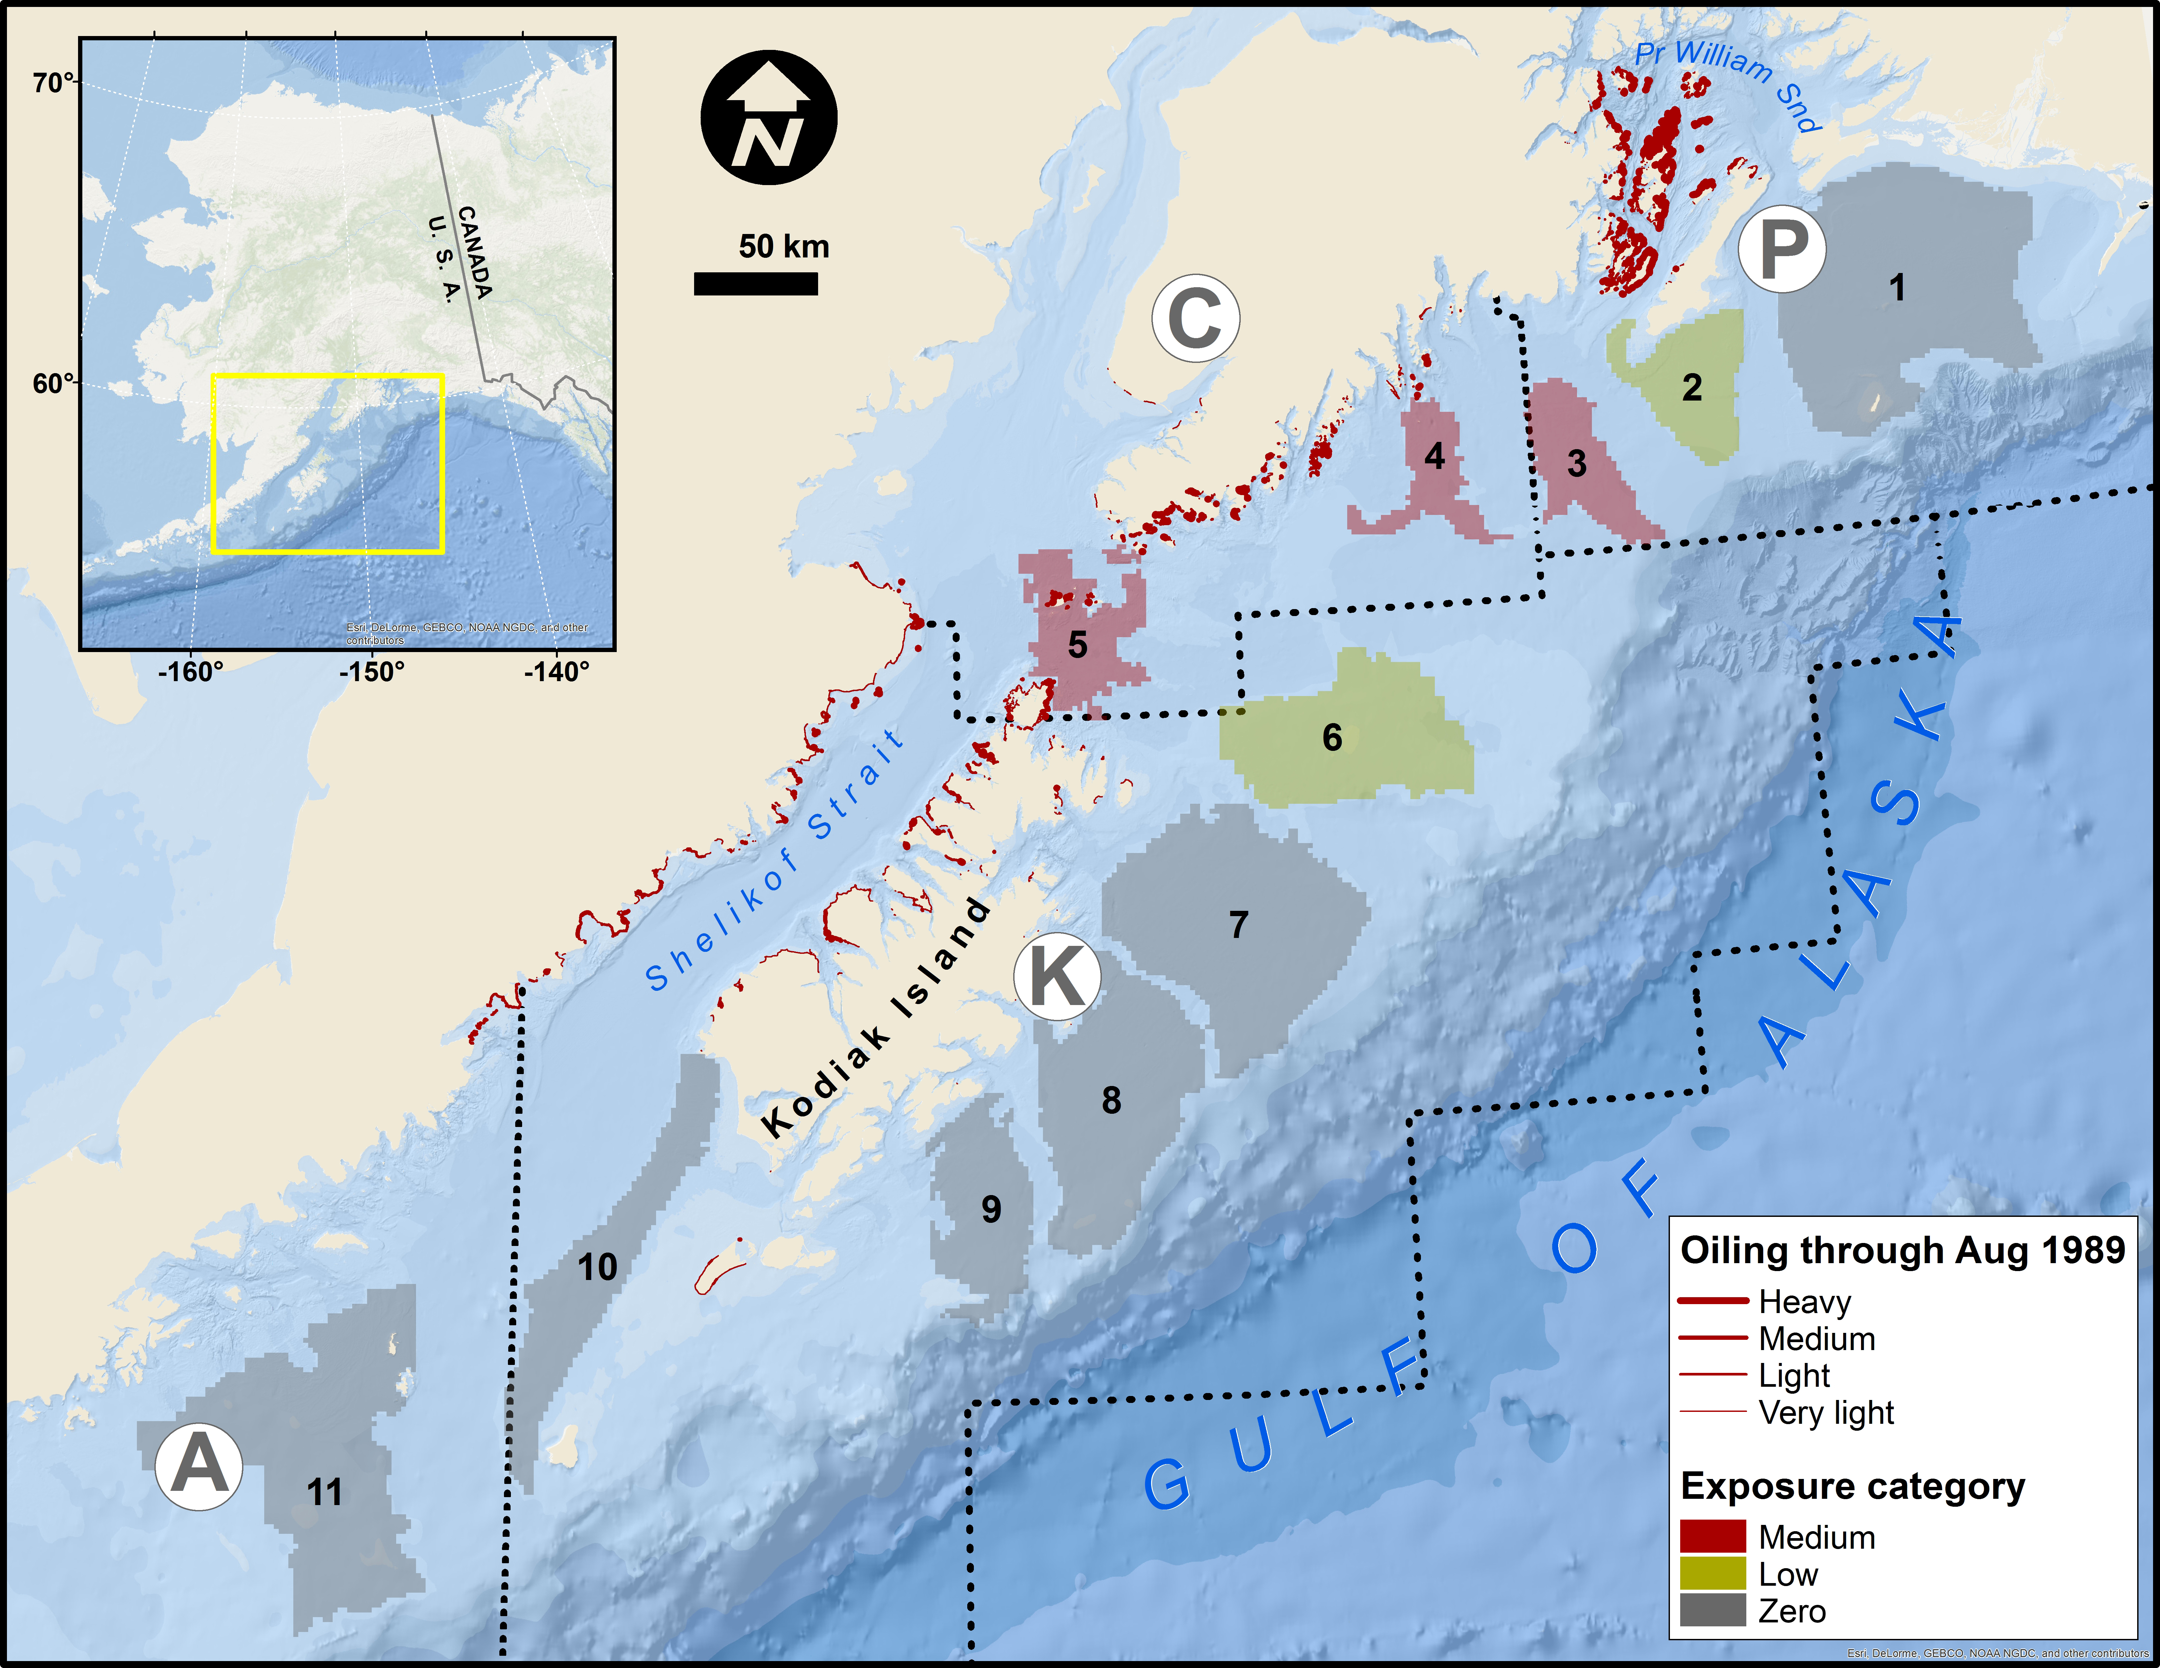

Figure 2. Mean estimated CPUE for each of the 11 focal areas. Focal areas with known higher exposure to EVOS are in red (areas 3,4, and 5, see Fig. 1). Remaining areas are in black. Vertical dashed bar shows EVOS. Second row shows the time-series for the three guilds. The third row shows the three diet groups and the fourth row shows the species grouped by recruitment interval categories.



Figure 3. Area standardized groundfish catches for four major areas in the Gulf of Alaska. See Fig. 1 for



Fig. 4. Estimated linear trend for the 11 groundfish regions. Areas hypothesized to be most affected by EVOS are shaded darkly, the marginal areas of EVOS exposure have lighter shading. Each row shows the community broken up based on guild, diet category, or recruitment interval. Note that the values of the y-axis vary among panels.



Fig. 5. Estimated coefficient of variation (CV) for each of the 11 areas. See Fig. 3 caption for



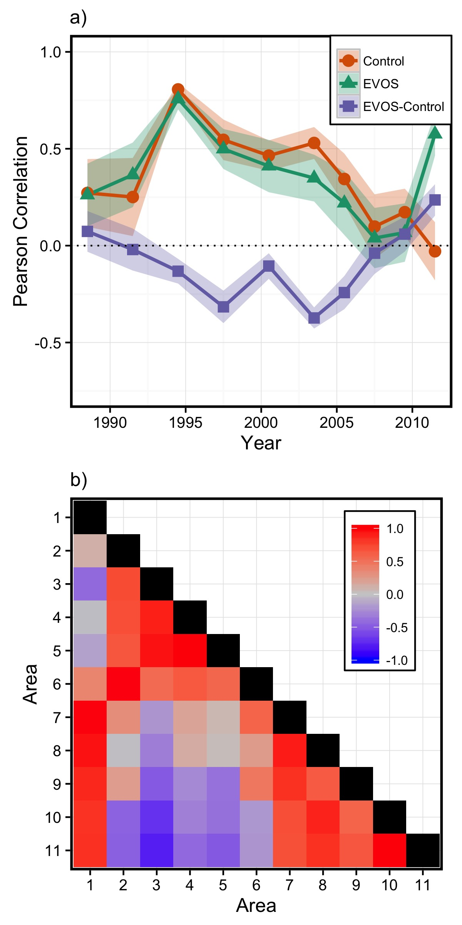

Figure 6: (*a*) Time-series of cross-correlations for total biomass using a nine-year moving window. Red line shows median cross-correlation among areas outside of the main EVOS spill (“Control”; areas 1 and 7-11). Green line shows median cross-correlation of all pairwise correlations in areas within the EVOS zone (“EVOS”, areas 2-6). Blue line shows median cross-correlation between areas within EVOS and the control areas (“EVOS-Control”). (*b*) Pairwise Pearson correlations between focal locations for total biomass for the period 1990-99. Red colors indicate positive correlations, blues indicate negative correlations and greys indicate approximate correlation of 0.